

Name: laraib salam
Sap id : 61996

Lab:12

Tasks :1

- Write an assembly program to print the following output using nested loops.
1) *****
****
***
**
*

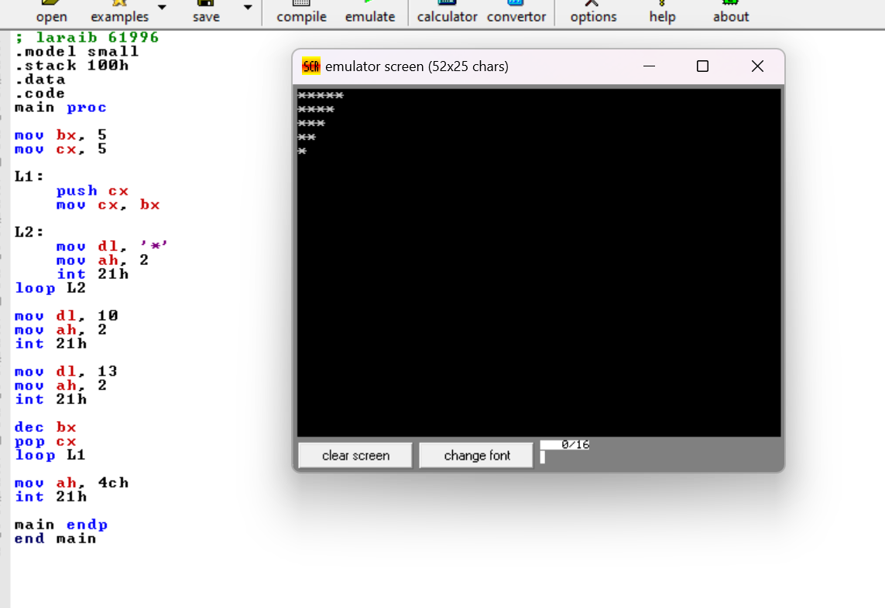

Tasks : 2
2) 1 1 1 1 1
1 1 1 1 1
1 1 1 1 1
1 1 1 1 1
1 1 1 1 1

